Follow our live coverage for the latest news on the coronavirus pandemic.

Outback amateur astronomers track planetary changes from Queensland backyards
ABC Capricornia
/
By Rachel McGhee
Posted 4hhours ago, updated 4hhours ago
YOUTUBEOutback amateur astronomers track changes on planets
Share

Amateur astronomers Anthony Wesley and Phil Miles aren't stargazers.
They are star gazers — two of only 50 or so backyard astronomers around the world who are so dedicated to watching and photographing the planets that professional astronomers rely on their observations.

Key points:
- Amateur astronomers in Queensland's Gemfields are two of about 50 in the world doing the work they do
- Anthony Wesley and Phil Miles spend hours every night in their backyard observatories tracking the planets
- Amateurs and professionals around the world are following a bright new storm on Jupiter, that was first seen on August 18
Every night they're in their backyard observatories, in Rubyvale in Queensland's Gemfields, using their homemade telescopes and other equipment to track changes on the planets, especially on Jupiter, Saturn and Mars.
"They're so rewarding because with a large telescope you can see the atmosphere on the planets," Mr Wesley said.
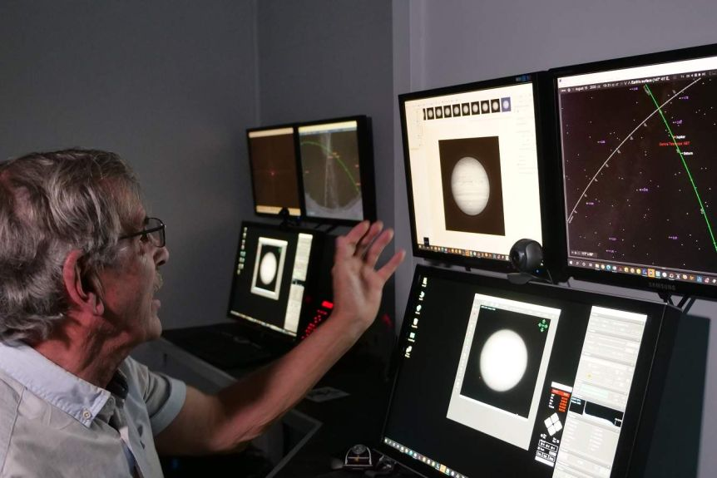
Phil Miles spends around six hours every night in his backyard observatory watching and photographing the planets.(ABC News: Rachel McGhee)
Mr Wesley, who built his telescope using mirrors, a metal frame and a camera, gained international recognition a decade ago when he was praised by NASA for capturing an image of a two-second flash of light on Jupiter. The flash was thought to be an asteroid strike, making Mr Wesley's photograph the first to capture a meteorite hitting a planet.
He has worked with NASA, the European Space Agency and the Japanese Space Agency and said professional astronomers often relied on amateurs to notify them "if something interesting starts to happen on one of the planets".
"It's quite common these days for amateur astronomers ... to have their images and data included in professional papers that get written in peer-reviewed journals," Mr Wesley said.
"We have lots of time on our hands ... and if you spend enough time looking at the planets you'll see something new perhaps that professional astronomers haven't seen."
Mr Miles, whose telescope 'Gemeye' is the largest of its kind in Australia, said there were two fields of amateur astronomy — deep sky and planetary.
"They use completely different techniques," Mr Miles said.
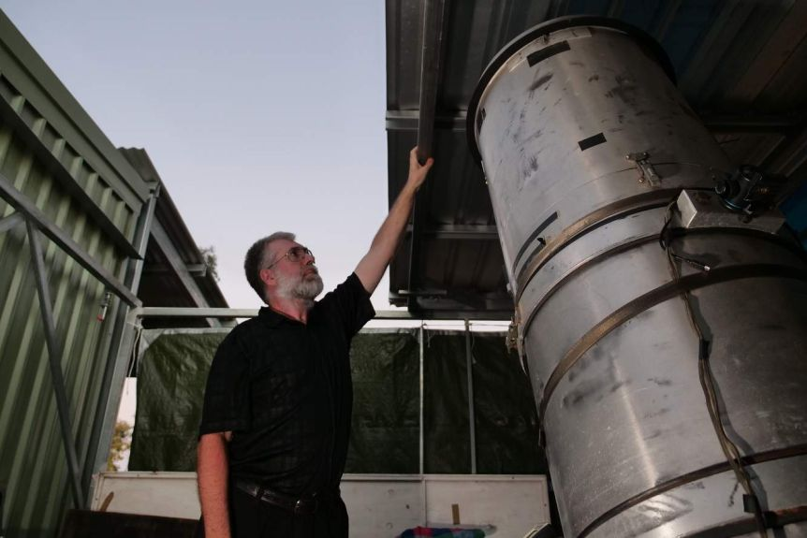
As the sun sets over his property at Rubyvale, Anthony Wesley prepares his telescope and planetary imaging equipment for the night ahead.(ABC News: Rachel McGhee)
"Worldwide, there are probably 50 amateurs doing this sort of work.
"Deep sky people — there's probably 500 or 1000 — and there's tens of thousands of people with telescopes that sit in cupboards that they don't use."
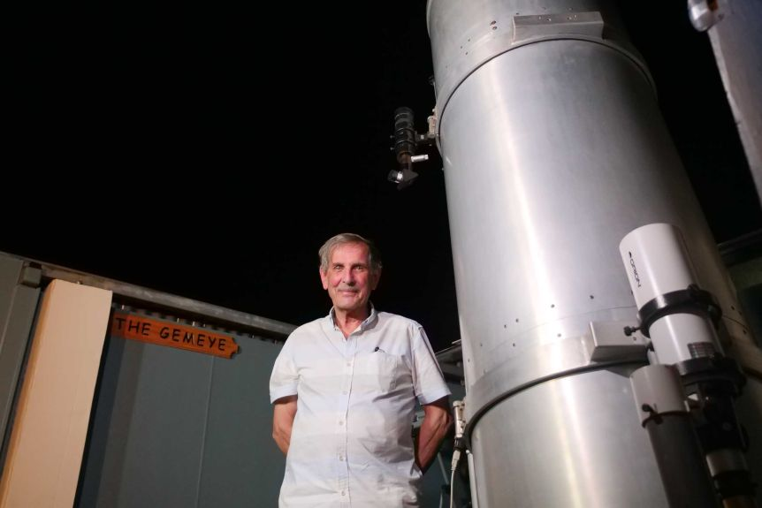
Amateur astronomer Phil Miles' telescope is the largest of its kind in Australia and is named the Gemeye.(ABC News: Rachel McGhee)

Jupiter's Great Red Spot captured
Mr Wesley moved to the small town of Rubyvale from Canberra three years ago, lured by the region's clear skies.
"Rubyvale is on the Tropic of Capricorn where you have the planets directly overhead in winter and the higher up the planets are in the sky ... the clearer the view that you get," he said.
The former software developer is regarded as one of the best in amateur astronomy.
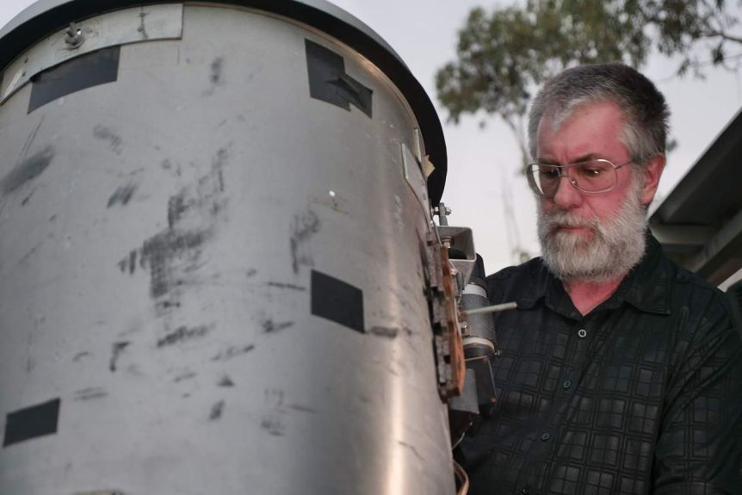
Anthony Wesley says looking up at the planets is incredibly rewarding.(ABC News: Rachel McGhee)
Last year, he again received high praise from professionals when he captured another historic planetary event — a change in Jupiter's centuries-old storm, known as The Great Red Spot.
"It went through a phase no-one had ever seen before, where it suddenly started misbehaving," Mr Wesley said.
"Instead of being a nice compact storm, it started changing shape, and there was some material that came off and it really looked like it was unstable.
"There was a period of time where everyone was wondering what was going to happen. Was it going to break up? Disperse? Is it going to shrink or get bigger?
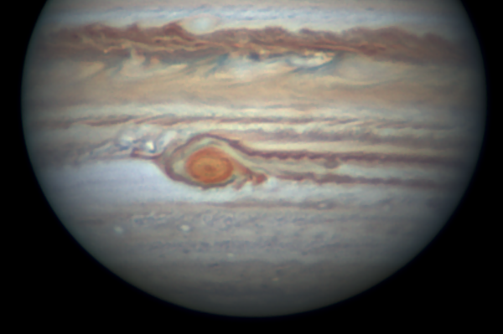
The change in Jupiter's storm, the Great Red Spot, captured by Anthony Wesley in May 2019.(Supplied: Anthony Wesley)
"It's just settled down again. But even so, it's still showing signs of not being back to its old self.
"So amateur and professional astronomers are watching it very closely to see what it might do next."

Tracking Jupiter's new storm
Over the past few weeks, Mr Wesley and Mr Miles have been tracking another change on Jupiter.
"One of the amateurs and a professional found a new storm," Mr Miles said.
"There's a bright spot, which is a new storm, which has occurred in the northern area of Jupiter, so we're all madly trying to image it.
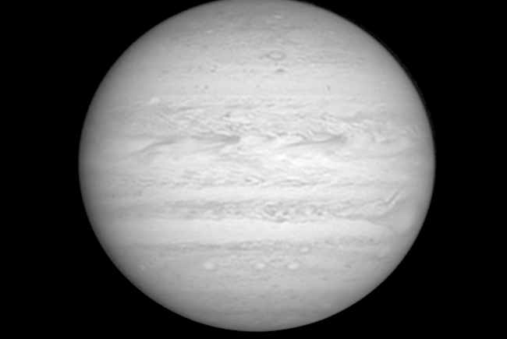
A new storm has been spotted on Jupiter in recent weeks, seen here in the upper left as a bright spot.(Supplied: Anthony Wesley)
"We're all very excited when something like that happens on a major planet."
Mr Wesley said the new storm appeared to be more energetic than previous ones.
"Storms like this new bright spot are enormous in real size. For scale, Jupiter is 140,000 kilometres in diameter, 11 times the diameter of Earth, and this new storm measures about 6000 kilometres across," he said.
"It would comfortably enclose all of Australia and New Zealand.
"It's possible that this is just the start of a sequence of eruptions. This is often how these events have unfolded in the past. [It's a] perfect time to look up at the sky."

Perfect time to look up at the night sky
For Australian astronomers, August and September are the best months for looking up at the sky because our 0solar system's largest planets, Jupiter and Saturn, are clearly on display.
Mr Wesley said this clarity made it possible for everyone to see Jupiter and Saturn.
"For anyone who's interested in the night sky and looking at planets, it's as simple as going outside," he said.
"You don't even need to go to a dark site, you can just go to your backyard.
"If they go out about nine o'clock at night and look up at the sky you can't miss them. Jupiter, Saturn, they look like two bright stars."
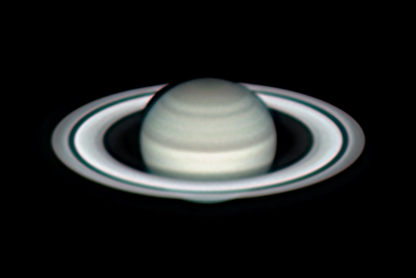
An image of Saturn Anthony Wesley took through his telescope this month.(Supplied: Anthony Wesley)

